ARA Enclosure Assembly Instructions

# Table of Contents

**Introduction** **1**

**Materials** **2**

**Instructions** **2**

**Changes Needed In The Future** **9**

# Introduction

This document serves as an instruction manual for the assembly of the ARA enclosure which contains a B210 SDR, 8 port Netgear switch, Intel NUC, Dell Precision 3240, 4 port power strip, amplifier, and transformer. The original design was done on a DPH-28713 enclosure, but the instructions are being modified for the larger DPH-28712. The acrylic panels are cut in the ABE lab in Sukup by [Hoa Chi](mailto:hmnguyen@iastate.edu) using a waterjet. This current model does not have a power relay module.

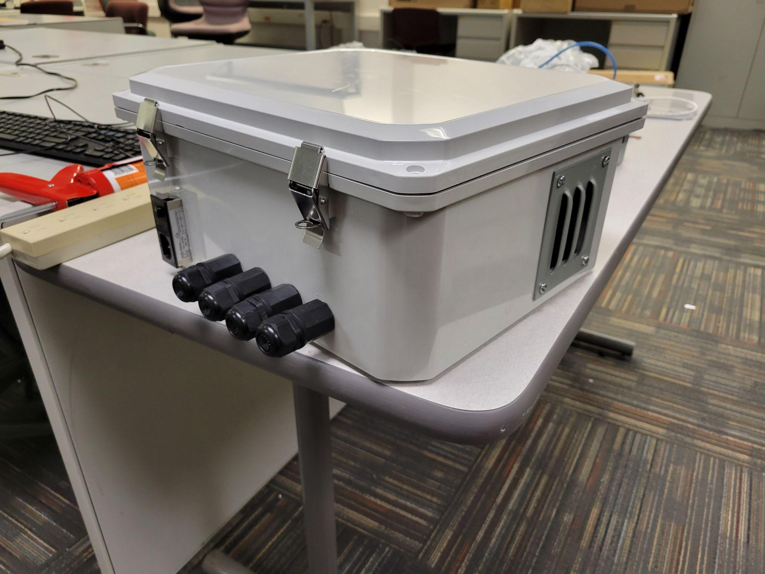

# Materials

* NI B210
* RF FrontEnd(PA+LNA)
* Netgear Switch
* Dell Precision 3240/SuperMicro computer[Experimenter computer]
* Intel NUC[Management computer]
* [Antennae](https://www.taoglas.com/product/apex-iv-wideband-5g-4g-dipole-antenna/)
* 12x M5x12mm screws
* 8x M3x25mm screws
* 8x M3x20mm screws
* 4x M3x5mm screws
* 4x M4x12mm screws
* 4x M3x30mm standoffs
* 4x M3x5mm standoffs
* 8x M3x10mm standoffs
* 20x M3 nuts
* DPX-444 kit
* [DPH-28712](https://www.budind.com/product/nema-ip-rated-boxes/dph-hinged-cover-ip68-nema-6p-pc-enclosure-with-adjustable-panel-height/ip68-nema-6p-pc-enclosure-for-adjustable-panel-height-dph-28712/#group=series-products&external_dimensions_group=0&internal_dimensions=0)
* 4x M20 waterproof ethernet connector female to male
* [2x Louver plate kit 3.88x4.5 in](https://www.alliedelec.com/product/nvent-hoffman/avk33/70305384/)
* .189” thick acrylic minimum 34”x30”
* [2x SMA cable 12”](https://www.amazon.com/Bingfu-Bulkhead-Cellular-Amplifier-Transmitter/dp/B08139CQLG/ref=sr_1_5?dchild=1&keywords=%3Cspan%2Bclass&th=1)
* [2x SMA cable 12” 2 right angles](https://www.amazon.com/SUPERBAT-2-Pack-Cable-Connector-Jumper/dp/B08C6Z12Q3/ref=sr_1_12?crid=10X6EYQETN1WM&keywords=SMA%2Bfemale%2Bright%2Bangle%2Bto%2BSMA%2Bmale%2Bright%2Bangle%2B12%22&qid=1649259720&s=electronics&sprefix=sma%2Bfemale%2Bright%2Bangle%2Bto%2Bsma%2Bmale%2Bright%2Bangle%2B12%2B%2Celectronics%2C100&sr=1-12&th=1)
* [Power entry module](https://www.digikey.com/en/products/detail/qualtek/762-18%2F002/417916?utm_adgroup=Power%20Entry%20Connectors%20-%20Inlets%2C%20Outlets%2C%20Modules&utm_source=google&utm_medium=cpc&utm_campaign=Shopping_Product_Connectors%2C%20Interconnects_NEW&utm_term=&utm_content=Power%20Entry%20Connectors%20-%20Inlets%2C%20Outlets%2C%20Modules&gclid=CjwKCAjw9LSSBhBsEiwAKtf0n9E1egTIERFg3ZrGitG2iKGPIgYgaGqAc-VfxpNqMJJqpMD8ry_rgBoCyVUQAvD_BwE)
* [Power strip](https://www.amazon.com/J-VOLT-1604-4-Outlet-Joules-20-Inch/dp/B013FC2FKM)

# Instructions

1. Get the panels cut from Hoa in the ABE lab. From our experience, he may have excess acrylic he is willing to use. If not, you will have to provide the acrylic yourself. (Source files for the acrylic panels can be found on our [senior design website](http://sdmay22-30.sd.ece.iastate.edu/))
2. Put all the components on the panels. The bottom panel should have the Dell 3240 and the power strip, the middle panel should have the switch, and NUC, and the top panel should have the power supplies, B210, amplifier, and transformer.
   1. NUC
      1. The NUC goes on the middle panel in the bottom left corner. It uses 25mm screws and 10mm standoffs. Put the screw through the bottom of the panel and put a 10mm standoff on the other end. Orient the NUC such that the ethernet port is facing the back of the enclosure. Put the NUC on the screws and then put 4 nuts on top of the screws. Don’t screw the nuts too tight or they will bend the NUC.

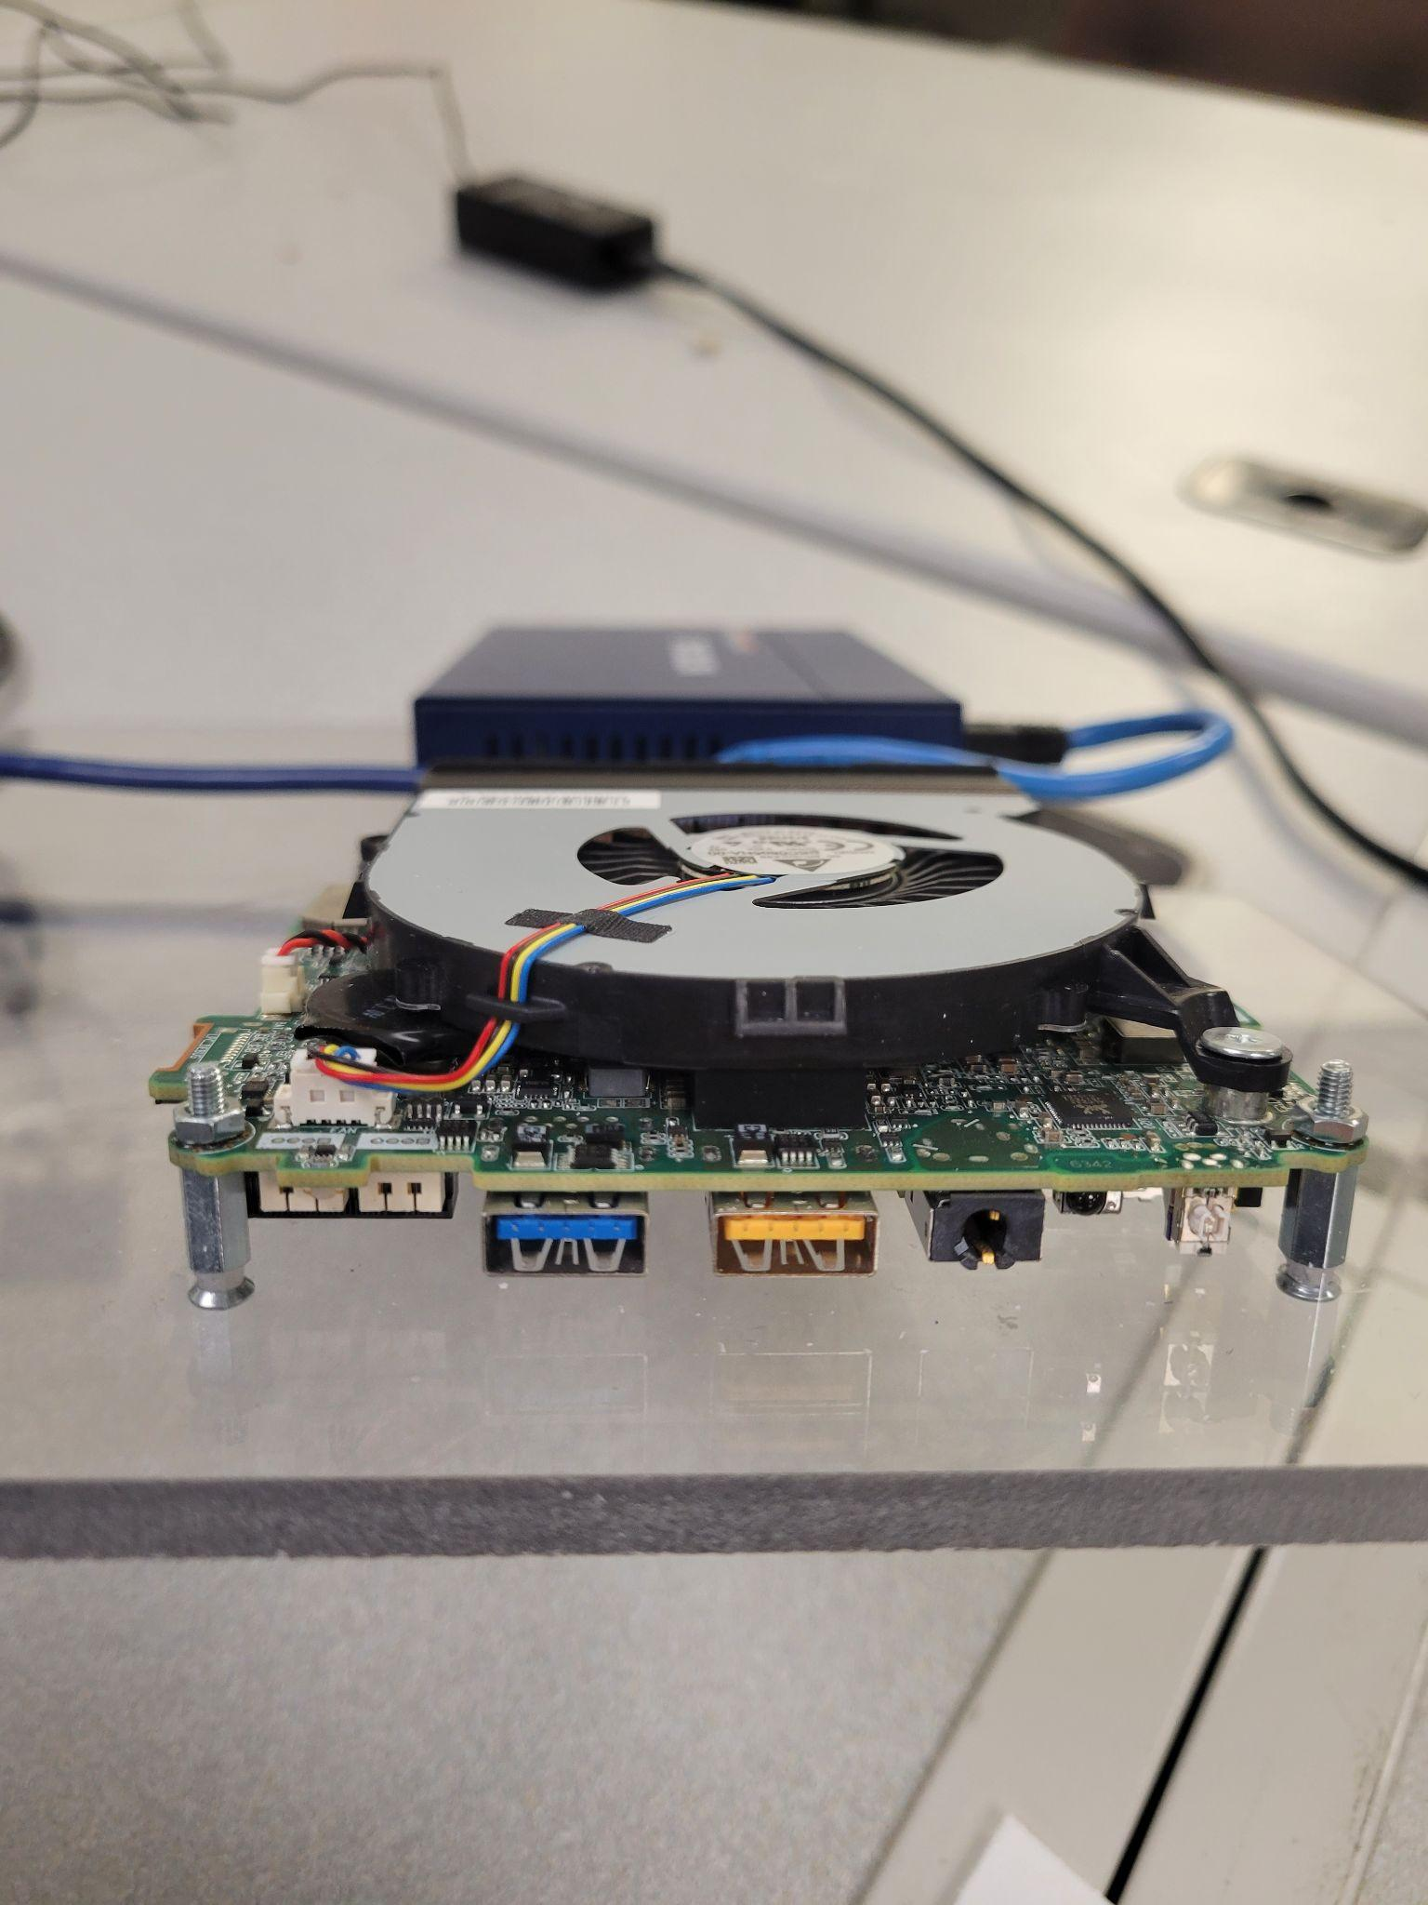

* 1. Switch
     1. The switch goes next to the NUC on the middle panel. The switch uses 2 20mm screws and 4 nuts. First put the screws on the switch by putting a screw into the mounting hole and tightening a screw onto it. Orient the switch such that the ethernet ports face the outside of the enclosure. Then put the switch on the panel and tighten another nut on the underside of the panel.

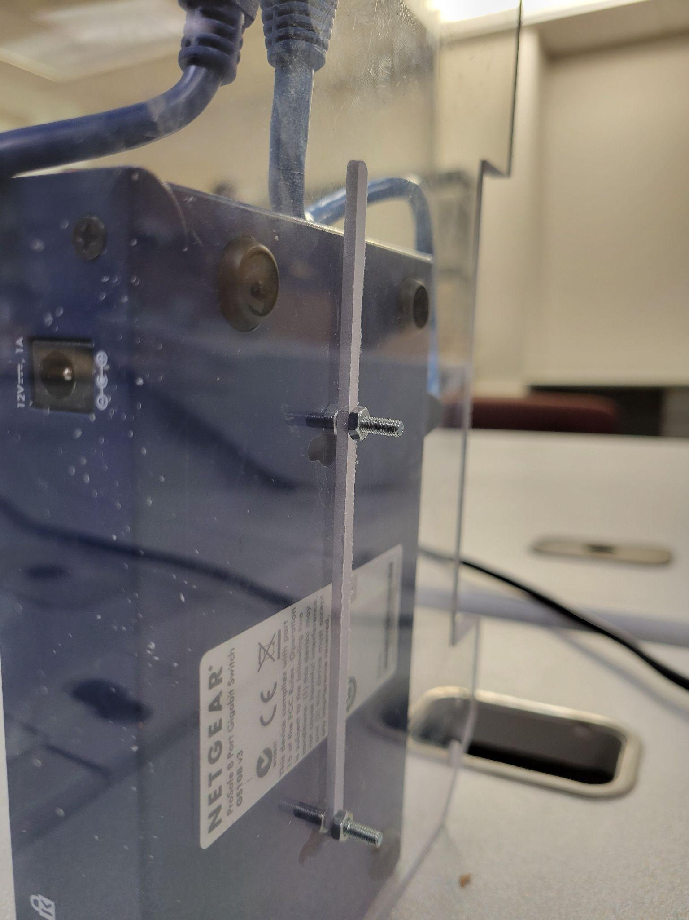

* 1. Transformer
     1. The transformer is very similar to the NUC in the mounting method. It goes on the top panel. Depending on the transformer used, it either goes in the bottom right corner or in the middle. It should use 20mm screws and 5mm standoffs.

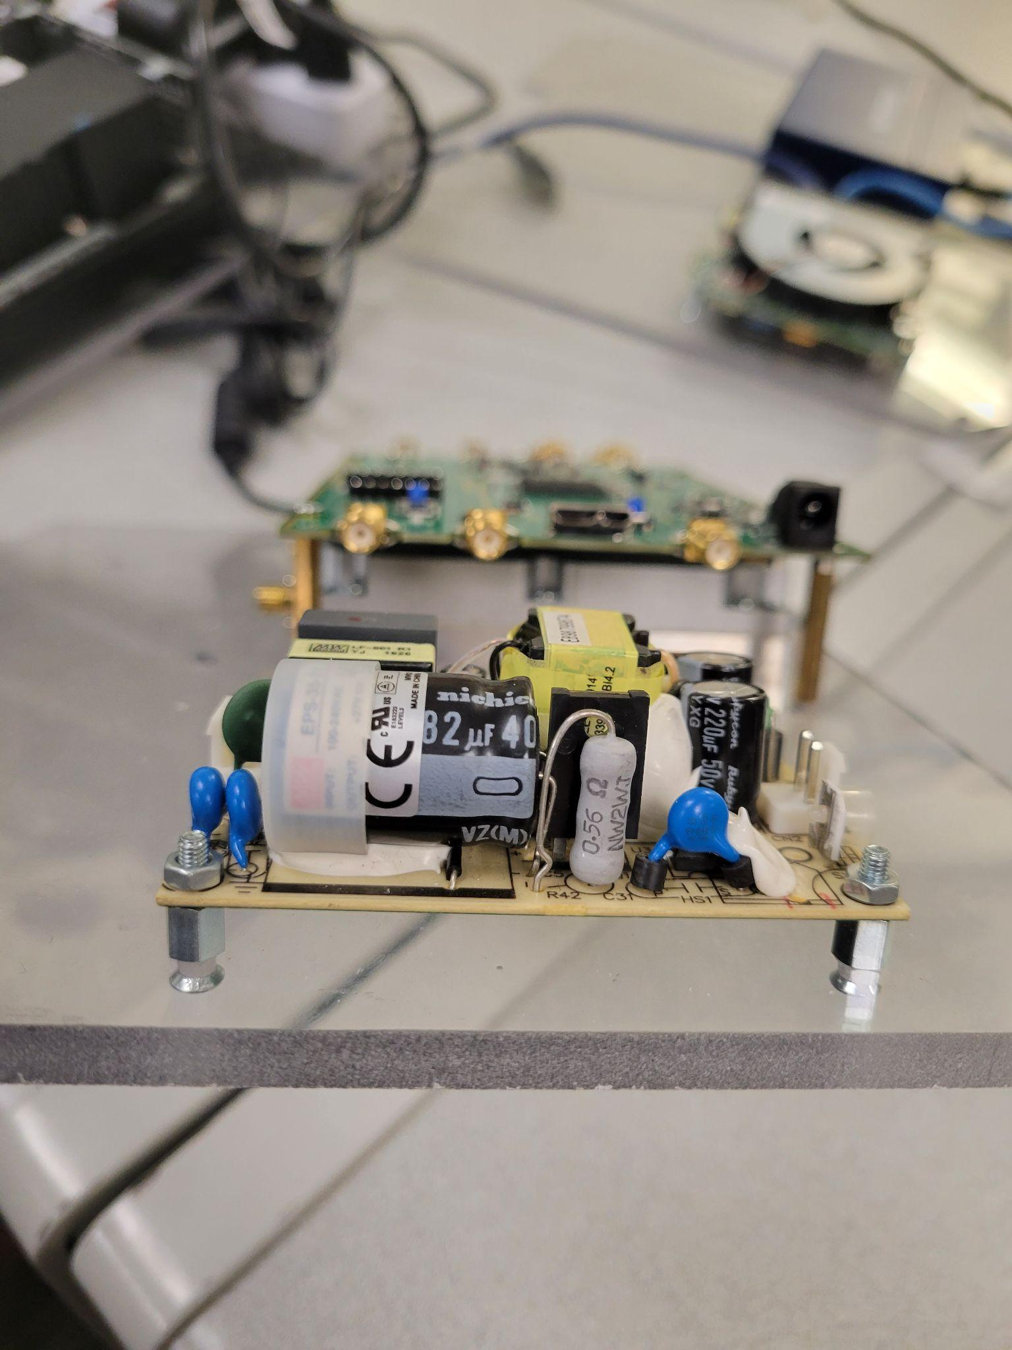

* 1. Amplifier
     1. The amplifier goes below the B210 on the top panel. It uses 4 25mm screws on the corners. Put the screws through the bottom of the panel and through the amplifier, then put nuts on top. Orient the amplifier such that the SMA ports are facing the inside of the enclosure.

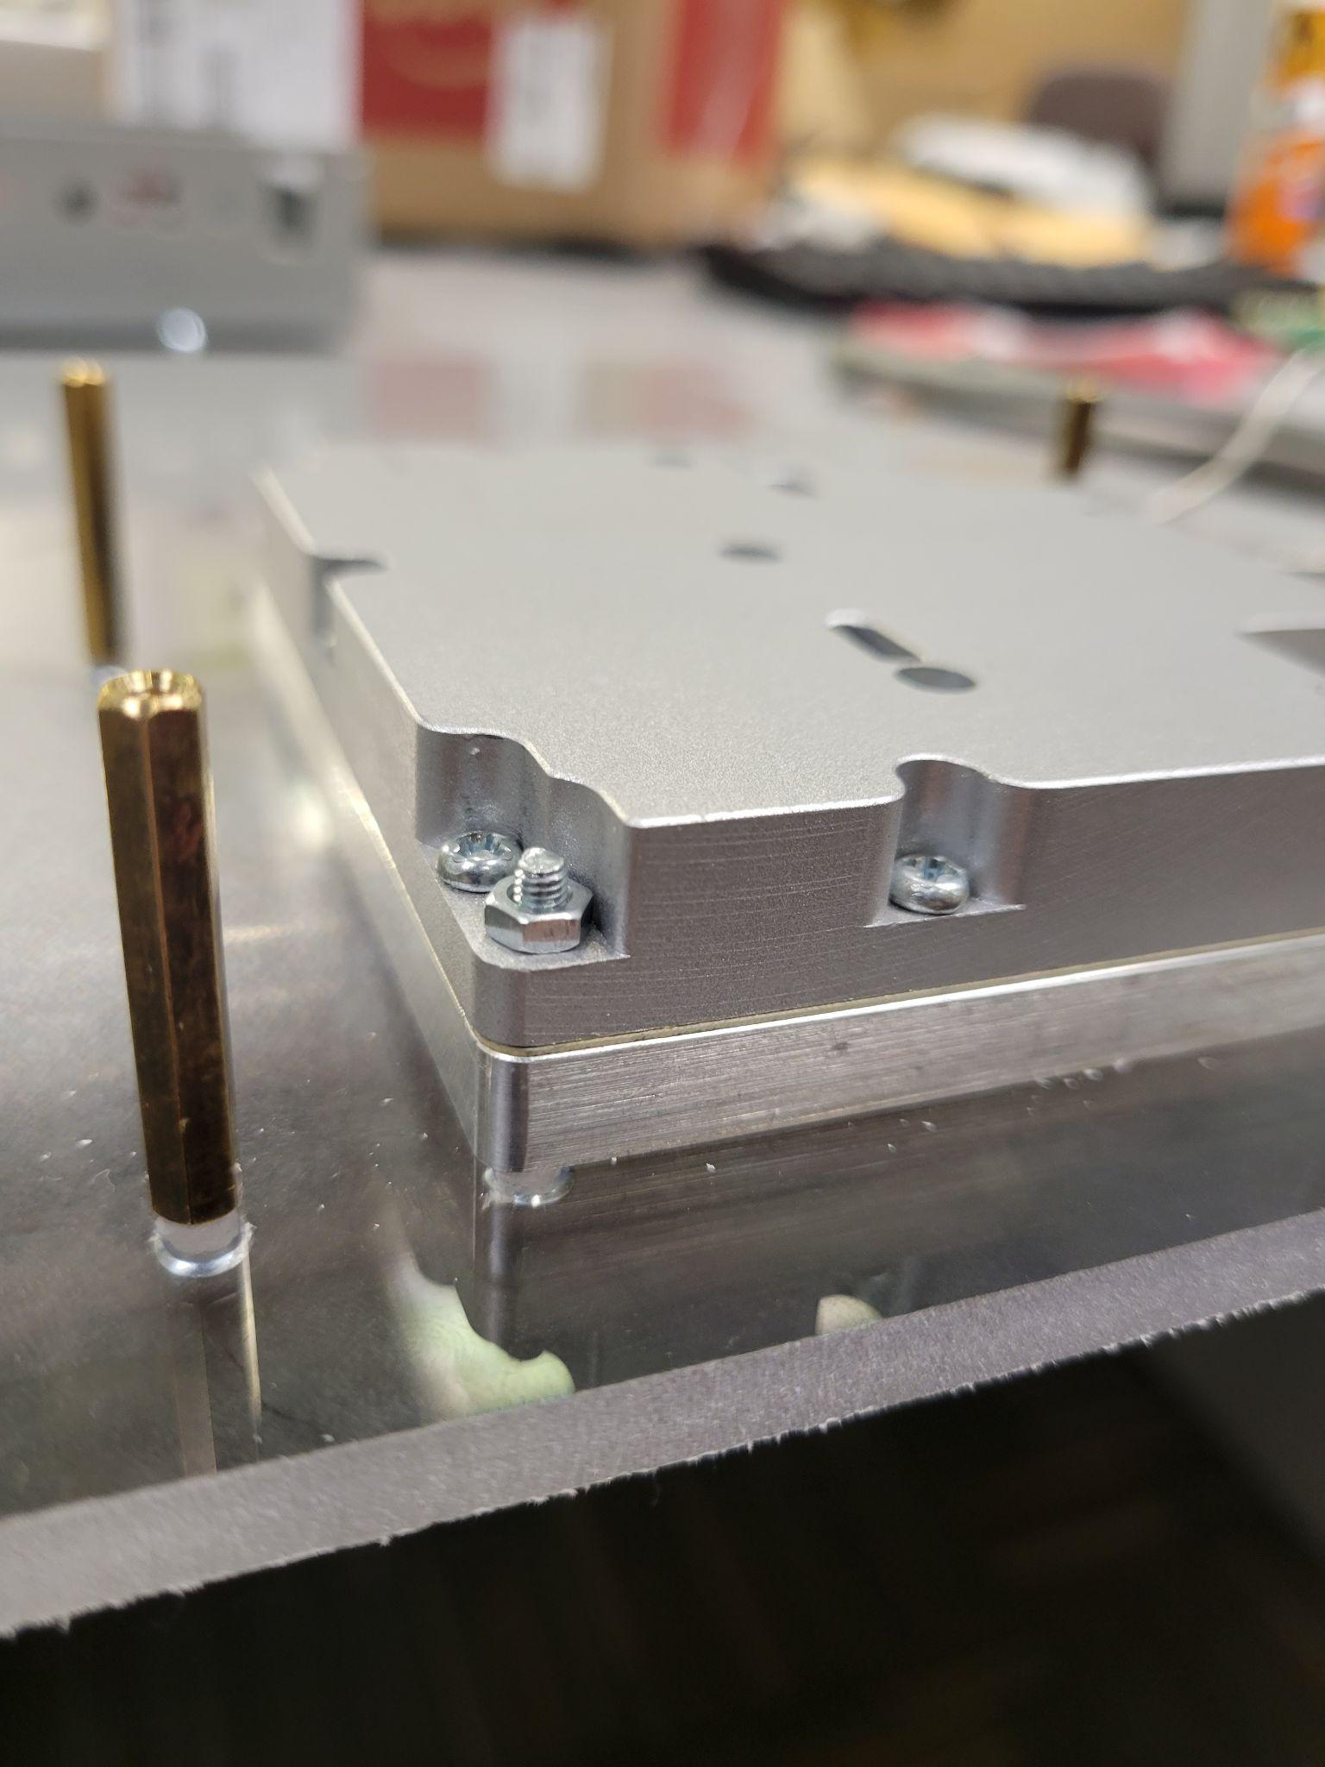

* 1. B210
     1. This goes on top of the amplifier using 30mm standoffs. Use 20mm screws to put the standoffs on the top of the panel. Then put the B210 on top and fasten it with 5mm screws. Orient the B210 so that the USB port is facing the front of the case.

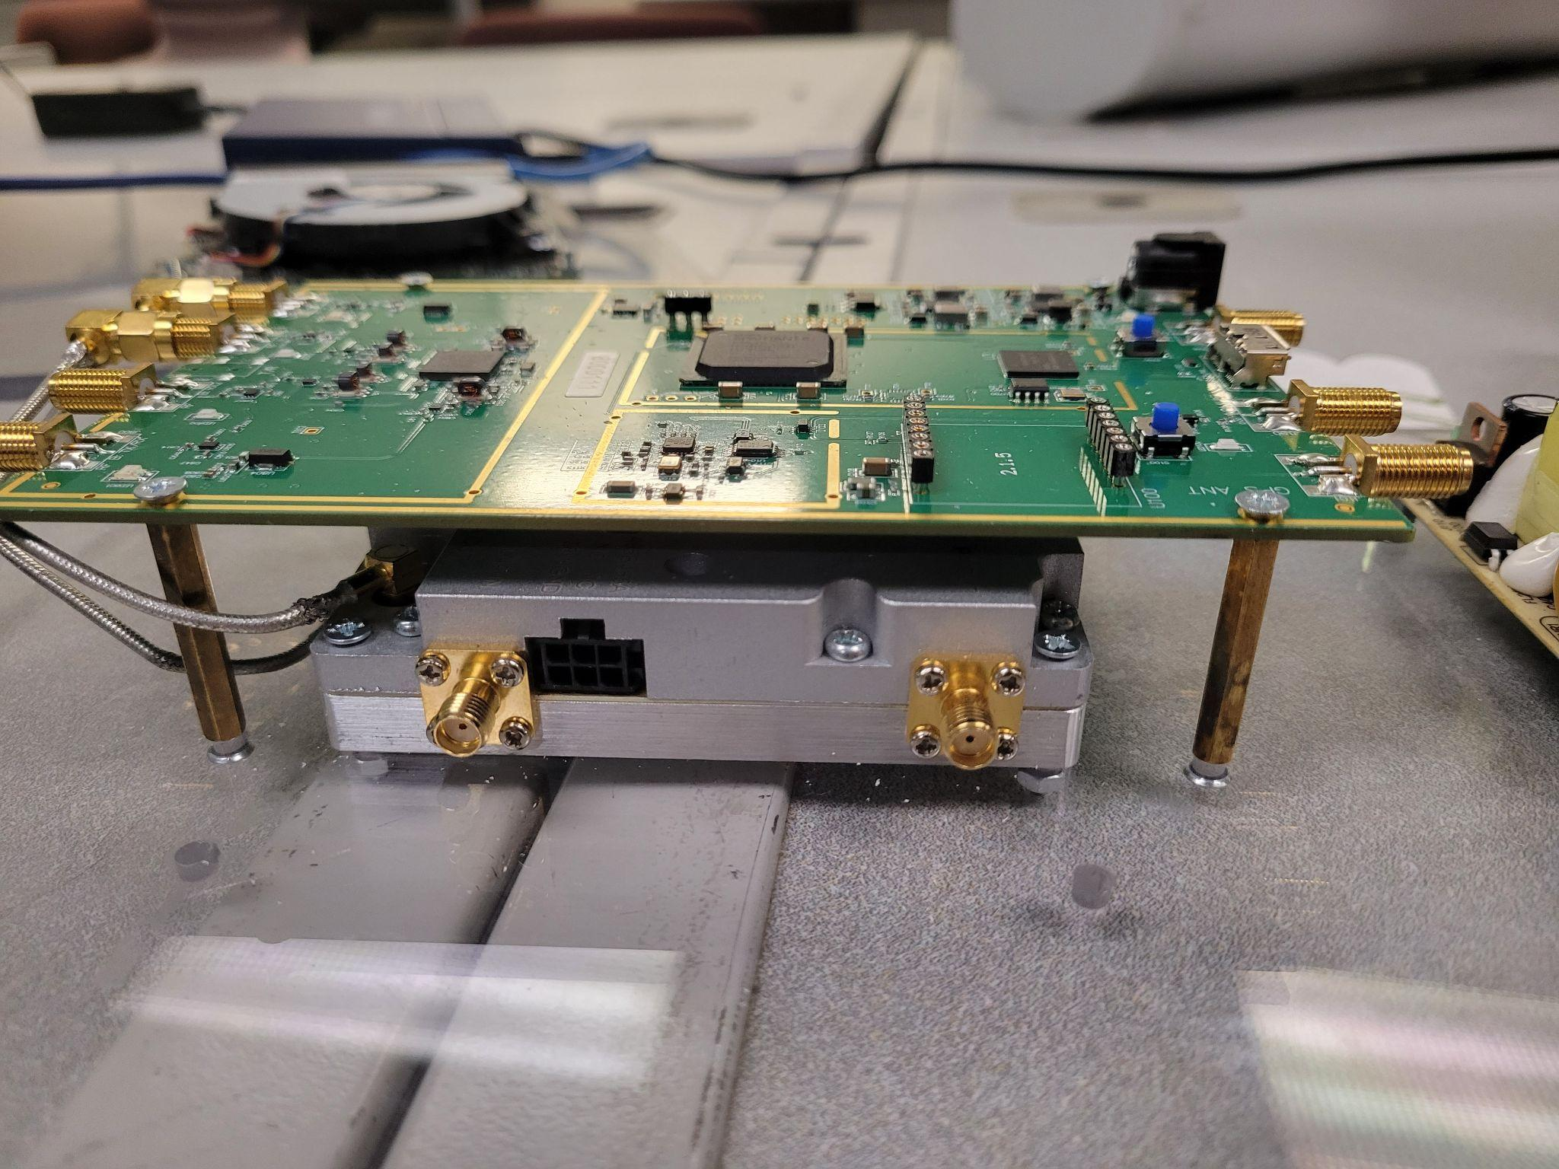

* 1. Dell Precision 3240
     1. The Dell goes on the bottom panel and uses M4 screws. It should be oriented such that the back of the computer faces the power strip.

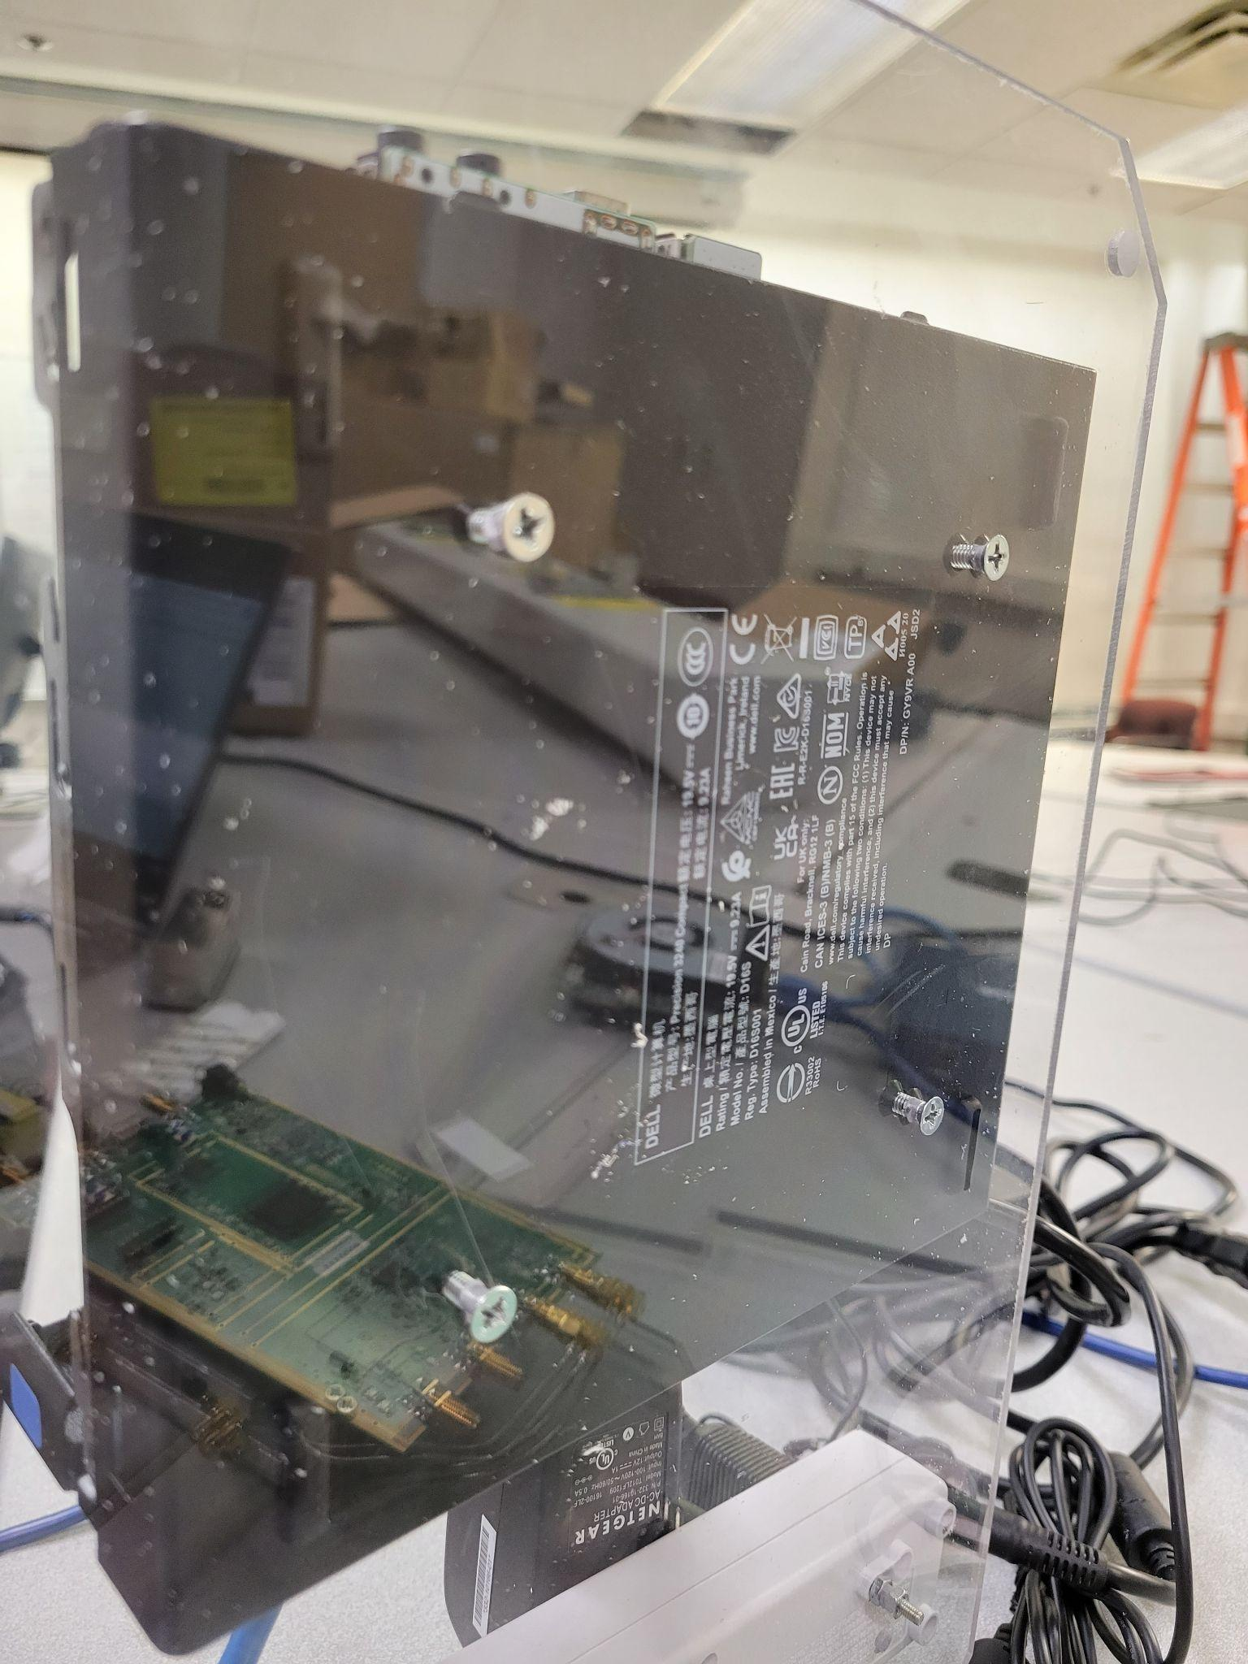

* 1. Power strip
     1. Mounted in a similar way to the switch. First put the head of the screw in the holes of the strip then tighten a nut on the screw. Put the screws through the panel and tighten another nut on.

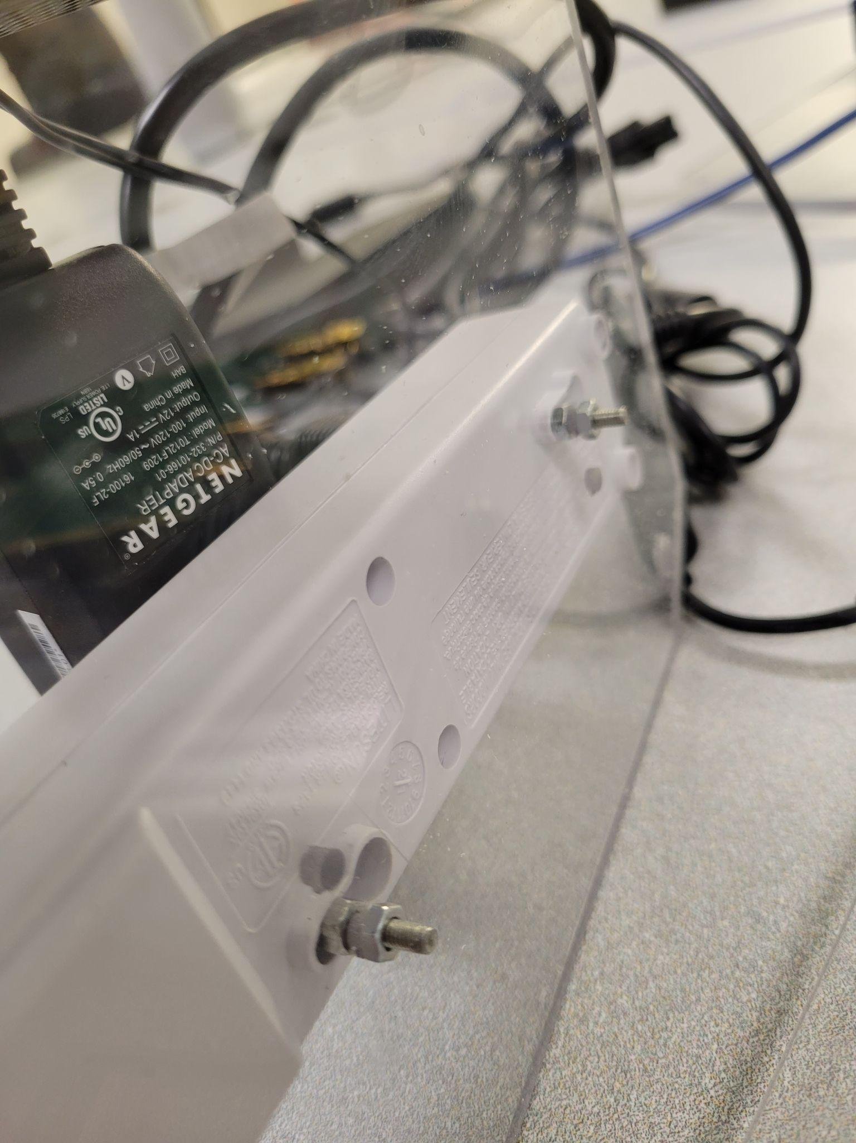

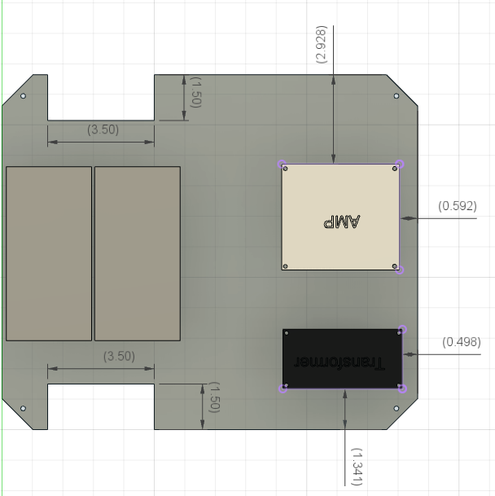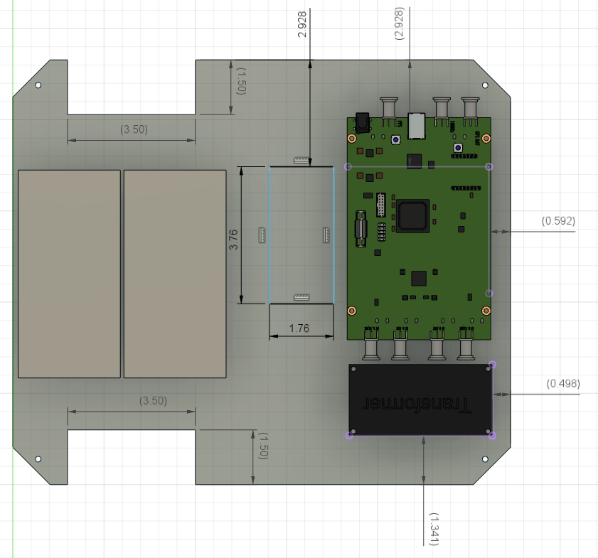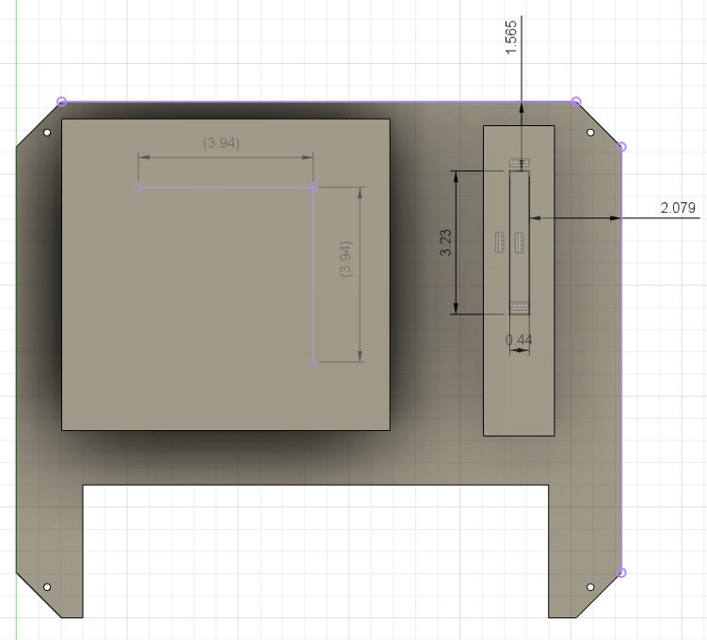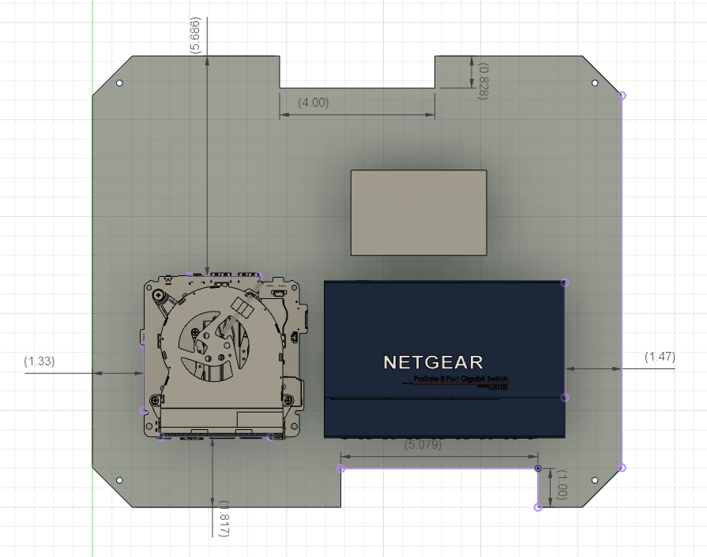

1. Cut the holes in the enclosure for vents, ethernet ports, and antennas
   1. Cut 4-5 holes in the front of the enclosure on the bottom for ethernet ports. These holes should be M20 in size, big enough to fit the threading through but not bigger than the gasket. A hole should also be placed on the bottom for the power entry module. Two holes for the vents should be on the sides on the top end. It should be two square holes for the vents and 4 holes in the corners for the screws. Finally, two holes need to be cut in the top of the case for the SMA cables used for the antennas.

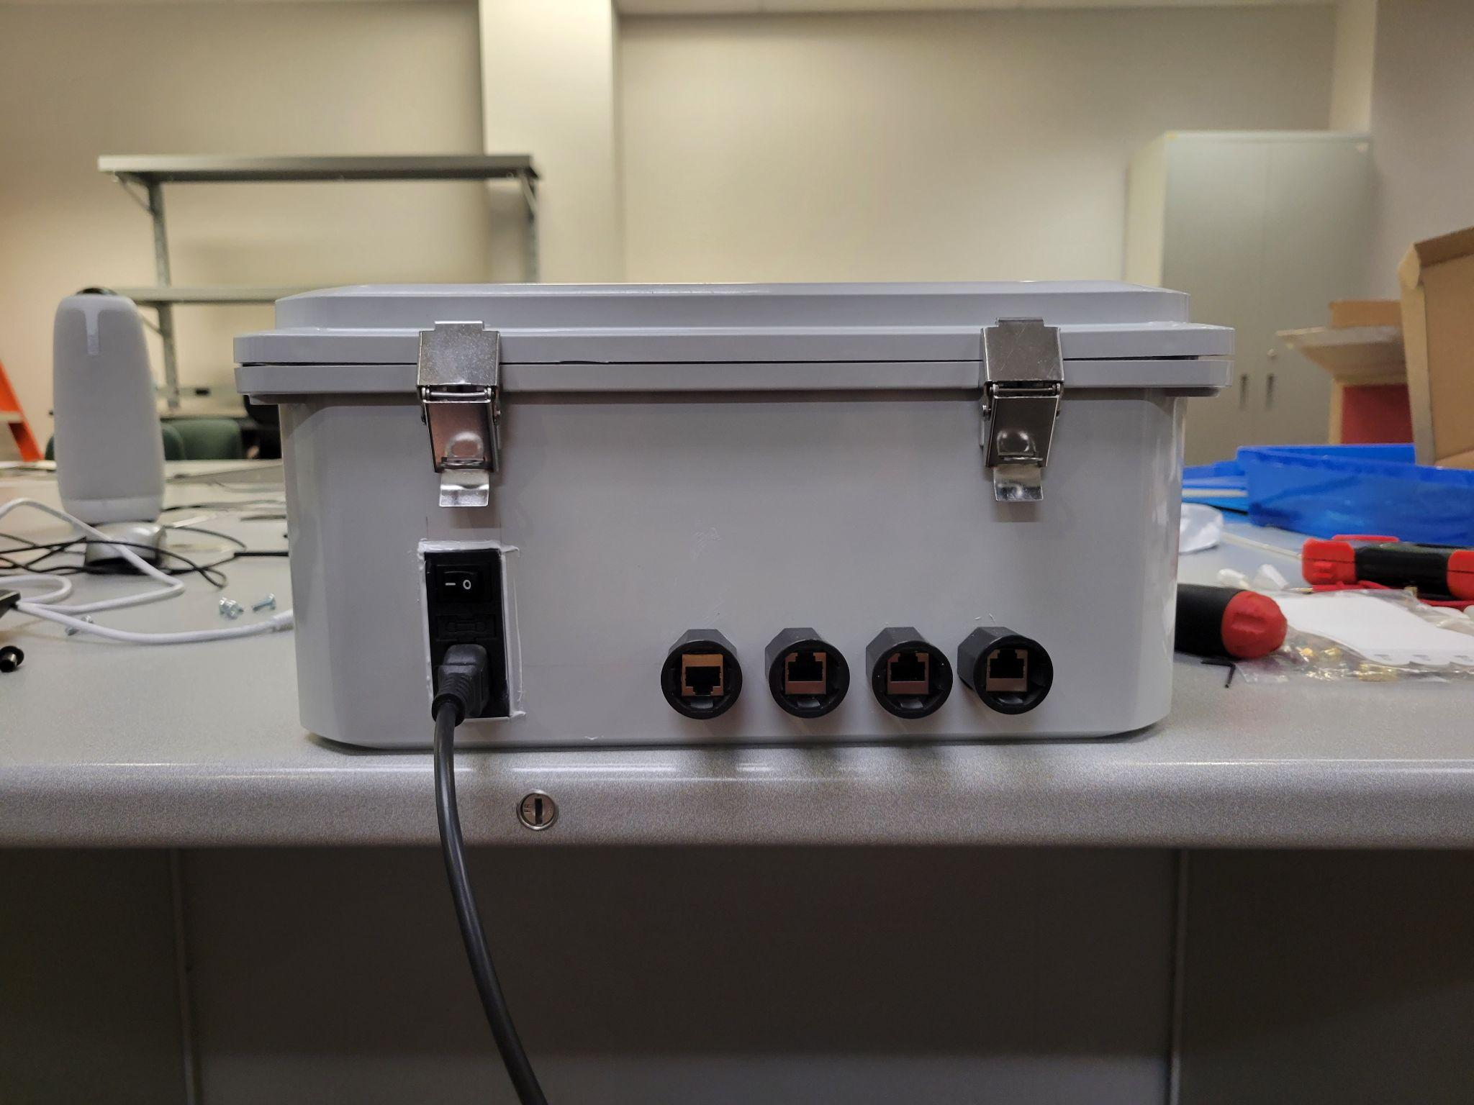

1. Splice the ethernet cables
   1. You will need to make your own ethernet cables to length for the connection between the NUC and the switch, Dell and the switch, and POE and the switch. [Here](https://www.youtube.com/watch?v=NmtMPSu--q0) is a walkthrough video on how to properly splice ethernet cables.
2. Solder the power connections
   1. Currently the model only uses a power strip without a relay. The power strip cable needs to be cut and soldered to the power entry module. Use the detachable wire connectors to connect the power entry module to the power strip. Green is ground, black is load, and red is neutral. It is VERY IMPORTANT that you match the wires from the power entry module to the strip. Also use heat shrinks to protect the soldered wire connections. 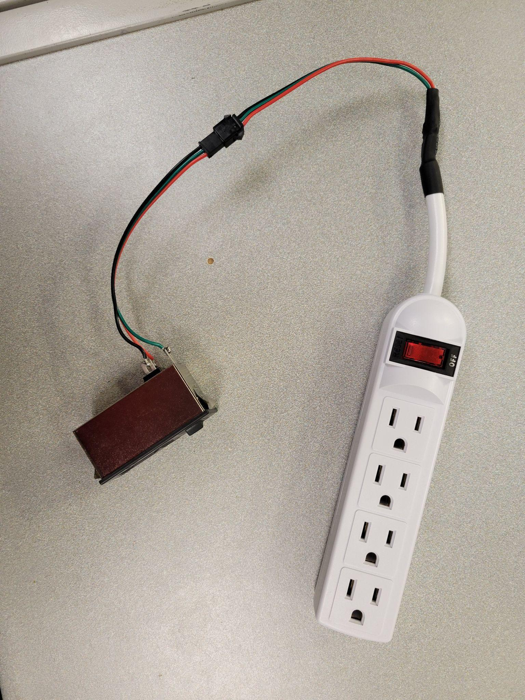

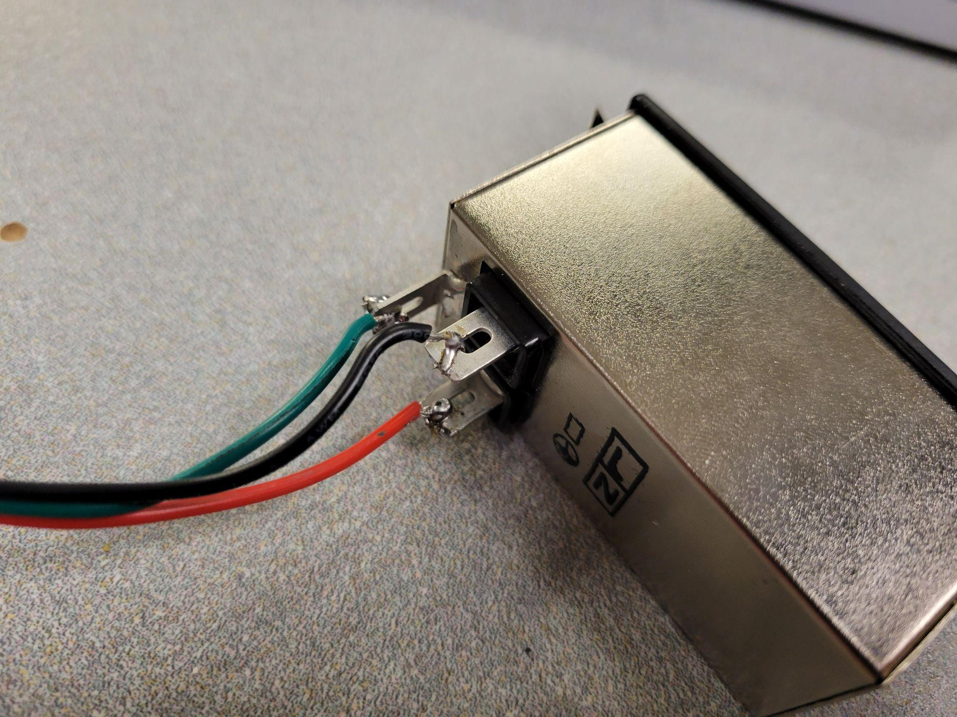

1. Put the hinges in the corners of the enclosure
   1. The hinges go in the corners of the enclosure. The bottom panel screws directly into the bottom and doesn’t need hinges.
2. Connect all the components
   1. This is the most complicated part of the assembly. All the components need to be connected in a specific order or else you won’t be able to put the next panel on. On the bottom panel, make sure all power cables are connected to the power strip, the ethernet cable and USB cable for B210 are connected to the Dell, the power strip is connected to the power module, and the Dell is connected to its power supply. Then put the second panel on, keeping the power cables on the side. Connect all the ethernet ports to the switch as well as the cables from the Dell and NUC, and connect power to the switch. Put the final panel on and connect the power to the transformer, USB to the B210, power cables to the power supplies for the NUC and Dell, and antennas from the AMP to the side of the panel.

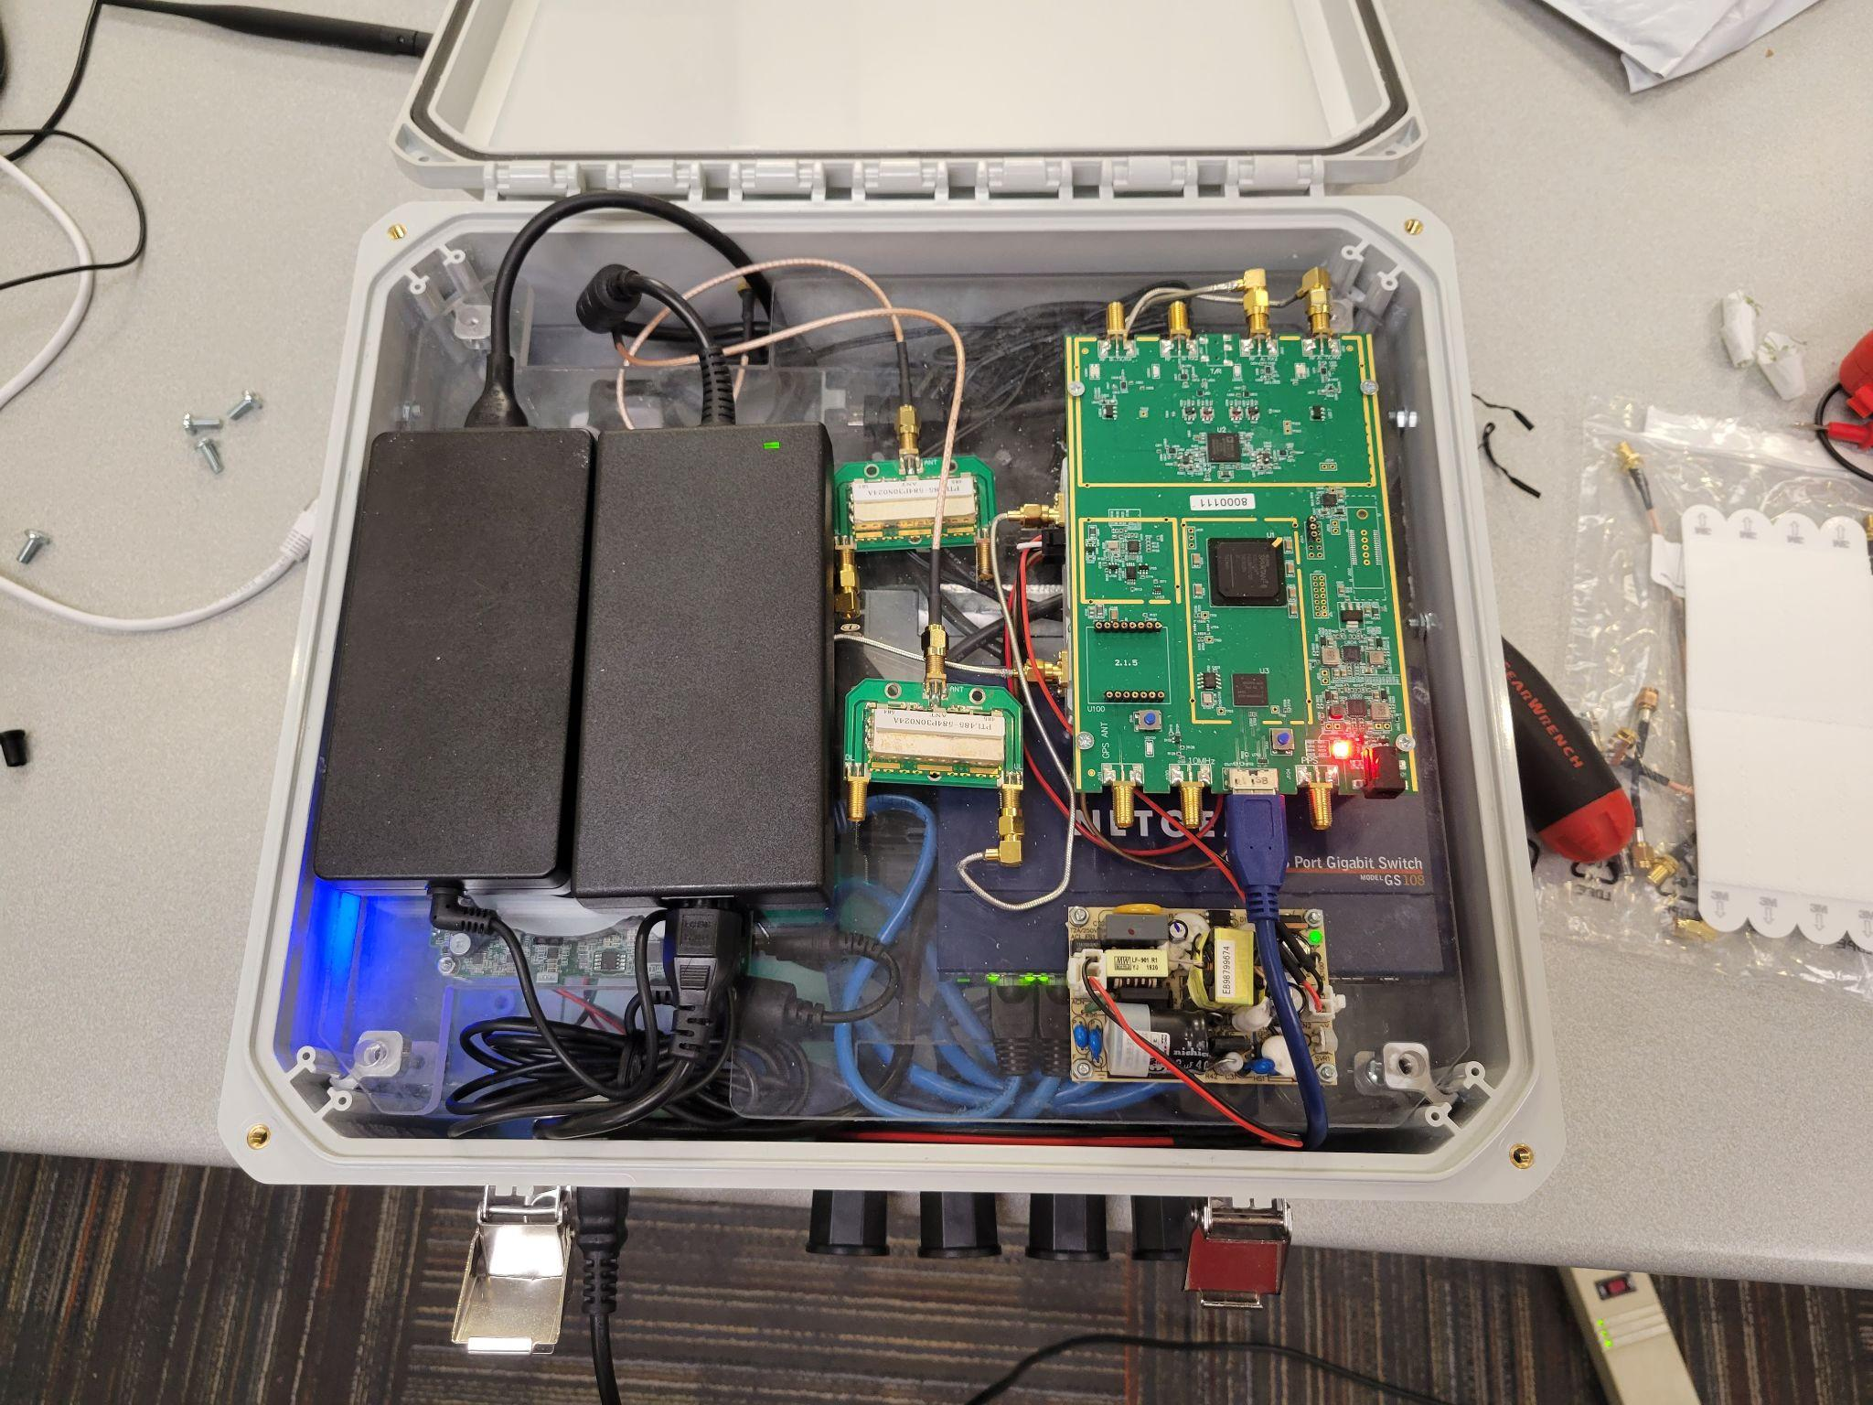

# Changes Needed In The Future

1. Fans: We noticed that the enclosure does get quite warm while under load. One thought is to add an 80-120mm fan on each vent to get some good airflow through the enclosure.
2. Filters: One good idea to implement is filters on the intake vents in order to prevent unwanted debris from getting inside the enclosure.
3. Vibrations: Some of these enclosures are going to be deployed on vehicles such as fire trucks and cyRides. These vehicles present another challenge of constant vibrations while the enclosure is deployed. To counteract this, some anti-vibration measures are going to have to be put in place to limit the effect the vibrations have on our screw mounts.
4. Power Supply Mounts: Currently, the power supplies for the two computers are command stripped down to the acrylic layer. These enclosures are supposed to be deployed for several years with minimal maintenance so these command strips should be replaced by something more robust. One idea is to get metal or 3d printed C mounts to mount down the power supplies from the top, connected to the acrylic panel with screws.
5. Skylark Mounting: We unfortunately did not have enough time towards the end of our project to mount the SkyLark mMIMO CPE to our enclosure. We planned for this to go on the top with the two antennas but it comes with a bracket to be mounted on a pole so some engineering is going to be needed to mount it on a flat surface.
6. Antenna Holes: We noticed that the antennas that we have on the top of the enclosure aren’t very “tight fitted”. Finding a better way to mount these cables to the outside of the enclosure would be best to ensure low maintenance over the years.